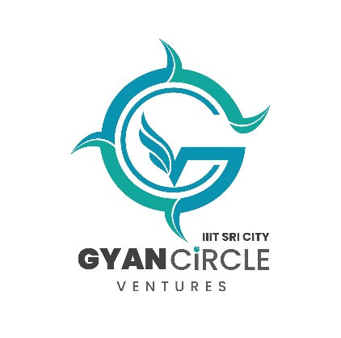
Gyan Circle Ventures

TIDE 2.0 Funding Opportunities
Gyan Circle Ventures proposal to function as a Technology Incubation and Development of Entrepreneurs (TIDE 2.0) incubation center was approved by the Ministry of Information Technology (MeiTy). They have chosen GCV as a Group 2 Centre.

TIDE 2.0 by MeiTy was initiated to promote tech entrepreneurship through financial and technical support to incubators engaged in using emerging technologies such as IoT, AI, Block-chain, Robotics etc. in pre-identified areas of societal relevance. You can learn more about TIDE 2.0 here: https://meitystartuphub.in/incubators/schemes/tide-2-0 . The TIDE 2.0 center at Gyan Circle Ventures will provide support for innovators and startups, in various phases, via the two following programs.

Entrepreneur-In-Residence (EiR) Program
- An Entrepreneurs-in-Residence (EiR) is an individual(s)/ student(s)/ start-up who are ready to develop and validate their idea into a Proof-of-Concept (POC).
- They will work from GCV incubator space
- GCV TBI will support the idea development, validation, and subsequent development of POC.
- A maximum up to Rs. 4 Lakhs will be provided to each EiR as Grant.

Grants Program
- Nascent start-ups with a definite Proof-of-Concept can be considered eligible for the grant. The grant is provided to create a Minimum Viable Product and to advance the start-up till Go-to-market stage.
- A maximum of up to Rs. 7 Lakhs may be provided to each start-up as Grant.
- GCV TBI will provide mentorship and guidance throughout the program.

Investments
- Later stage start-ups are eligible for investments for a tune of Rs 40 Lakhs.
- The grant is provided to proceed with moving the product towards commercialization.
- Allocation of funds for investments are common to all 20 TIDE2.0 group-2 centers. It is subject to additional scrutiny and approval from MeiTy.

Contact us at gyancircle.ventures@iiits.in. Please indicate your query clearly in the subject line for faster processing of your queries. Please refer to our website for application documents.

